Single File |  | Staggered Formation |  | Hazard in Roadway
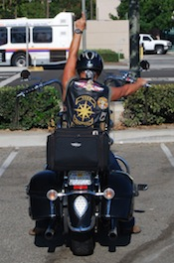 |  | 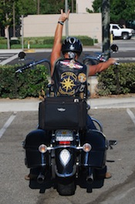 |  | 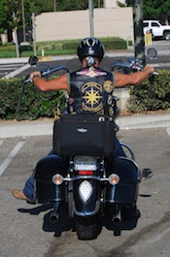 |  | 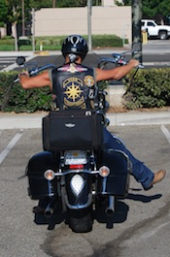
When you see this sign, assume the Single file formation. The Road Captain will call for single file formation when the road narrows and/or becomes curvy. To see an example of a Single File formation, click here. |  | When you see this sign, return to the track you held in staggered formation and close distance. The Road Captain has determined the road is safe for this formation. To see an example of a Staggered formation, click here. |  | To the left |  | To the right
 |  |  |  | Careful, there's something on the road. You aren't pointing directly at the hazard necessarily, but in its general direction.
Tap-Out |  | Slow Down |  | Move Left |  | Move Right
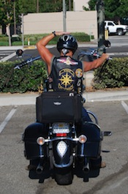 |  | 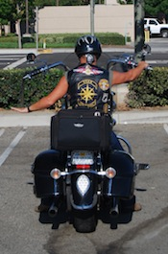 |  | 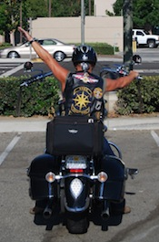 |  | 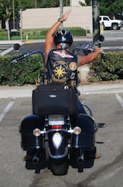
A rider will use this sign when they need to pull over due to bike malfunction or personal issue or if breaking off from the group. This signal is NOT passed back. The tail gunner will drop out of formation when the rider starts to drop out. It is important not to pass this signal back so as to avoid confusion. |  | When you see this signal, decrease your speed and keep pace with the rider in front of you. |  | When you see this sign, move to the far left of the lane and keep an eye out for an object on the right side of the road; once you are past the object return to your track. The Road Captain will not signal you to return.  To see a video of this lane change - Click here |  | When you see this sign, move to the far right of the lane and keep an eye out for an object on the left side of the road; once you are past the object return to your track. The Road Captain will not signal you to return.  To see a video of this lane change - Click here
Rear Fill Left |  | Rear Fill Right |  | Front Fill Left |  | Front Fill Right
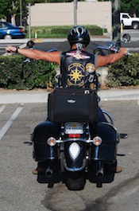 |  | 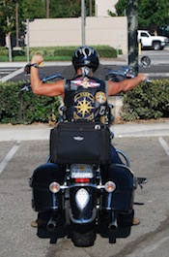 |  | 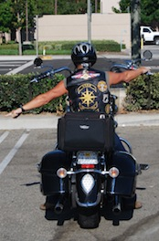 |  | 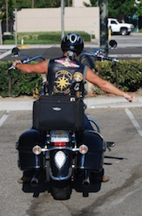
When you see this signal, please pass it back and make sure the people behind you see it (i.e. Leave it out there for two seconds after the person in front of you drops their hand).  After this, watch your rear view mirror. This lane change begins with the tailgunner, after the person behind you moves left you are cleared to move as well. The Road Captain is the last person to move.  To see a video of this Lane change - Click here |  | When you see this signal, please pass it back and make sure the people behind you see it (i.e. Leave it out there for two seconds after the person in front of you drops their hand).  After this, watch your rear view mirror. This lane change begins with the tailgunner, after the person behind you moves right you are cleared to move as well. The road Captain is the last person to move.  To see a video of a Right, Rear Fill Lane Change - Click here |  | Occasionally you will see the Road Captain make this signal, then move left. This usually occurs when passing a slower vehicle.  When this occurs, simply accelerate with the rest of the group and move left when you get to the slower vehicle.  Please remember, your safety is paramount, if you do not feel safe moving in front of the vehicle, move left behind the vehicle. The Road Captain will adjust their speed and allows the group to reform. |  | Occasionally, you will see the Road Captain make this signal, then move right. This usually occurs when passing a slower vehicle.  When this occurs, simply accelerate with the rest of the group and move right when you get to the slower vehicle.  Please remember, your safety is paramount, if you do not feel safe moving in front of the vehicle, move right behind the vehicle. The Road Captain will adjust their speed and allows the group to reform.  To see a video of this lane change - Click here
Close Up
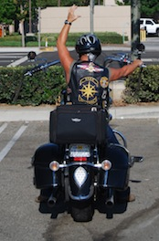
This sign is used to bring the group into a tighter formation.

